|  |  |
| --- | --- |
|  | Timberline field Documentation Manual |
|  |  |
| Sage | For Internal Use Only |
|  | This document serves as the documentation manual to assist in data entry procedures via the Project Management module in Sage 300 CRM. |

For Internal Use Only

Table of Contents

Field Reports 3

Creating a New Field Report 3

Tabs 3

Employee Time 6

Quality Control 7

General 7

Definable Features Of Work (DFOW) 7

Determine Required Inspections 7

Log DFOW in Timberline 7

Update DFOW Log from Meeting Information 8

Printing Reports 9

QC Log 9

QC Near Miss and/or Deficiency 9

Forms & Documentations 10

DFOW Example 10

Initial Phase Checklist Example Finial or Follow-up Phase Checklist Example 11

Equipment Start-up Checklist Example Concrete Pour Checkout Example 11

Safety 12

GENERAL 12

Project Sign 12

Tool Box Talks 12

Safety Tip 12

Lost Time 13

Safety Audits 13

Logging into Timberline 13

Near Miss & Deficiency 13

Logging into Timberline 13

Printing Reports 14

# Field Reports

Sage 300 CRE (Timberline) incorporates a field reports data entry log. This log (called “Field Reports”) can be found under the “Documents” folder in Project Management. Upon opening up the Field Reports log, each log will be filtered by project. Select the appropriate project you would like to view/work with.

## Creating a New Field Report

* From the Field Reports list window, select “New”.
* Select the job from the drop down menu
* Enter the current date
* Enter the person preparing the report
* Type will default as “Daily Report”
* Assign the field report a number if required

### Tabs

Within each field report, you will be able to enter data for each of the following:

* Weather/Site Conditions
* Subcontractors
* Equipment
* Materials
* Work Activities and Progress
* Extras/Work Orders/Change Orders
* Events
* Visitors
* Journal Entries

#### Weather/Site Conditions

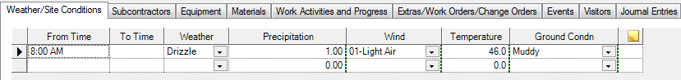

#### Subcontractors

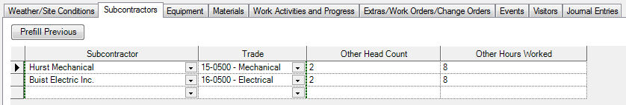

When entering the Subcontractor, if the Subcontractor is not shown in the drop down list. You may type any subcontractor in this field. When doing so, Timberline will prompt you to Create a Contact.

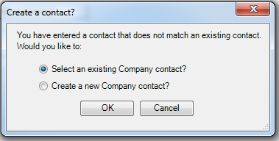

Select “OK” to Select an existing Company contact, which will bring up the following prompt (from the Address Book):

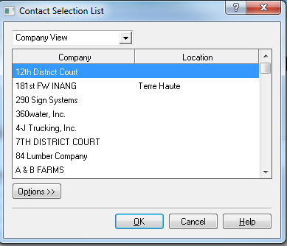

You could either use the scroll bar at the right to scroll through and find the contact you are looking for, or start typing the name of the company, which will act as a find function. From this point, type as much or as little as you need to locate the appropriate subcontractor.

Once you have your Company listed, select the Trade from the drop down menu. Complete the head count (total employees for this company) and hours worked (hours per day they were on site).

#### Equipment

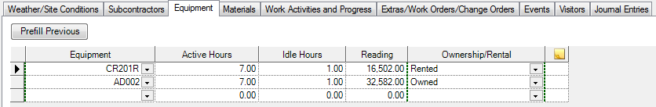

#### Materials



#### Work Activities and Progress

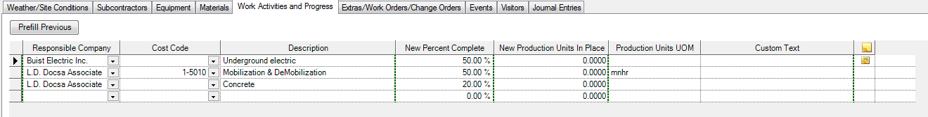

#### Extras/Work Orders/Change Orders

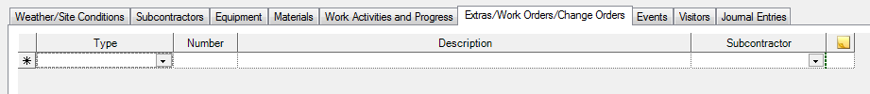

#### Events



#### Visitors



#### Journal Entries

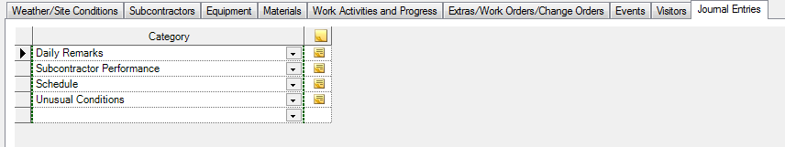

# Employee Time

# Quality Control

## General

The QC Forms will serve as the checklists for each Definable Feature of Work (DFOW). The DFOW will be put together based on the project by the project manager. This documented list will lead the Quality Control Inspection log.

## Definable Features Of Work (DFOW)

### Determine Required Inspections

As noted above, the DFOW should be logged into Timberline, with each item including the necessary required inspections. The standard inspections will be: Preparatory, Initial and Follow-up (or Final). Additional inspections may include Concrete Pour Checkout and/or Equipment Start-up Checklist. The Project Manager will determine which inspection should be included for each DFOW. An example is as follows:

|  |  |  |  |  |  |  |
| --- | --- | --- | --- | --- | --- | --- |
| ***Category*** | ***Description*** | ***Prep*** | ***Initial*** | ***Final*** | ***Concrete*** | ***Start-up*** |
| A. Sitework | 1) Excavation of ______ | X | X | X |  |  |
| A. Sitework | 2) Site Concrete | X | X | X | X |  |
| B. Equipment | 1) Flowmeter | X | X | X |  | X |

### Log DFOW in Timberline

Once the DFOW list is complete, these items shall be logged into Timberline. From the Tasks Tree in the Sage Desktop, Open (+) Project Management, Documents, Custom Logs, and select “Quality Control”.

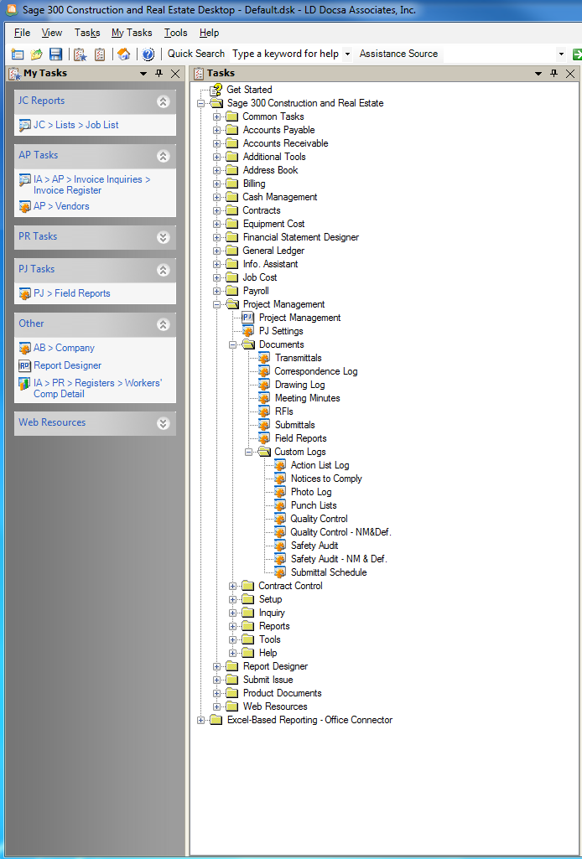

This will open up a data entry form to preload all DFOW, with the appropriate inspections, as determined above. It is important to note the job name at the top of the data entry form, and make sure you are entering your information under the appropriate job. When entering the log, utilize the following columns:

* Category (Must include letter (i.e., A, B, C, etc.) preceding Category)
* DFOW No. (Must be number represented prior to description of DFOW)
* DFOW Description (Include number and description)
* Phase (Prep, Initial, Follow-up (or Final))
* Status (When entering log, status should be “Open”

The category column will be exactly as stated. It is important to utilize a letter (A, B, C) preceding each description for sorting purposes on the reports. The DFOW log display as:

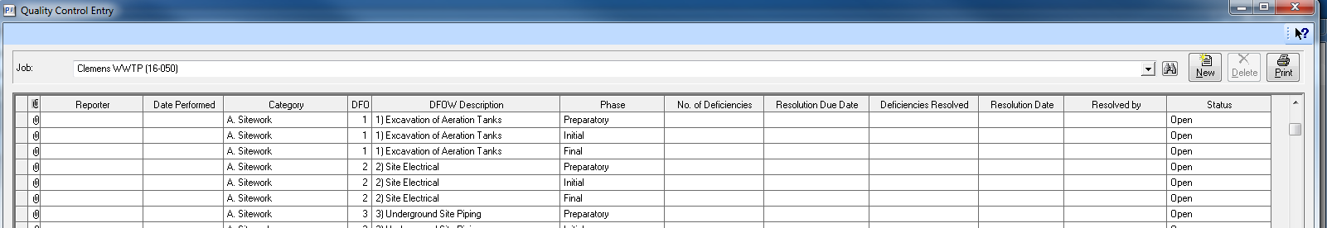

### Update DFOW Log from Meeting Information

Prior to work starting on any of the DFOW, a preparatory meeting must be held, in accordance with the QC Plan. During this meeting, the “Preparatory Phase Checklist” must be completed. In addition to the Preparatory Phase Checklist meeting, there will be two (or more) additional meetings. One for the Initial Phase work and one for the Final Phase work. There are checklists associated with each phase of the QC Plan, and an example of these checklists can be found in the back of this document.

The way in which this form is completed can be determined by the user. Once the meeting is complete, the remaining information open on the log must be completed (i.e., Reporter, Date Performed, No. of Deficiencies (if any), Resolution Due Date (if any deficiencies), and status. If no deficiencies are documented, the status should be changed to “Closed”. In the event deficiencies are found, the status is to remain open until deficiencies are resolved.

#### Logging Deficiencies

When deficiencies are noted, these items must be logged into the Quality Control Near Miss and Deficiency Log. This log is found under the same file structure in the Sage Desktop, with the name “Quality Control – NM&Def.”

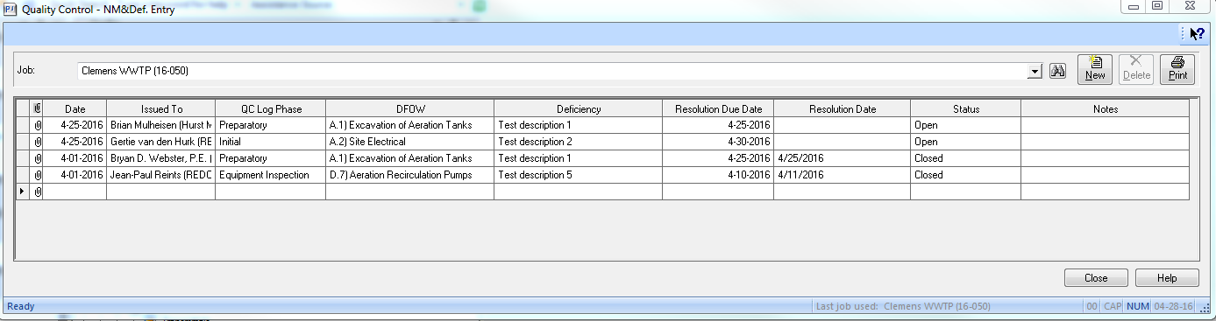

Once the deficiencies are resolved, the resolution date and status must be changed in the “Quality Control – NM&Def.” log as well as the “Quality Control” log. The status and date of resolution must be noted on both data entry forms.

## Printing Reports

Reports can be found under the Report Folder in the Sage Desktop Task Tree.

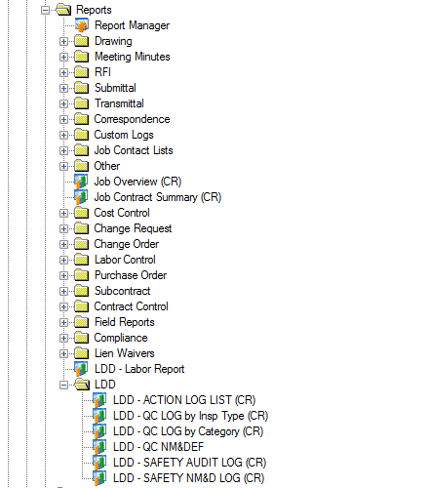

### QC Log

There are two types of reports created for the QC Log. One report is sorted by Inspection Phase Type/Status (Preparatory, Initial, Follow-up (or Final), etc.). This report is called “LDD – QC Log by Insp Type (CR). The other report is sorted by the Category noted on the DFOW. This report is called “LDD – QC Log by Category (CR)”.

### QC Near Miss and/or Deficiency

An additional report was created for the Near Miss and Deficiencies found during the phase meetings. This report is called “LDD – QC NM&DEF”, which is located under the same folder in the report tree. This report is sorted by status.

An example of each report is as follows:

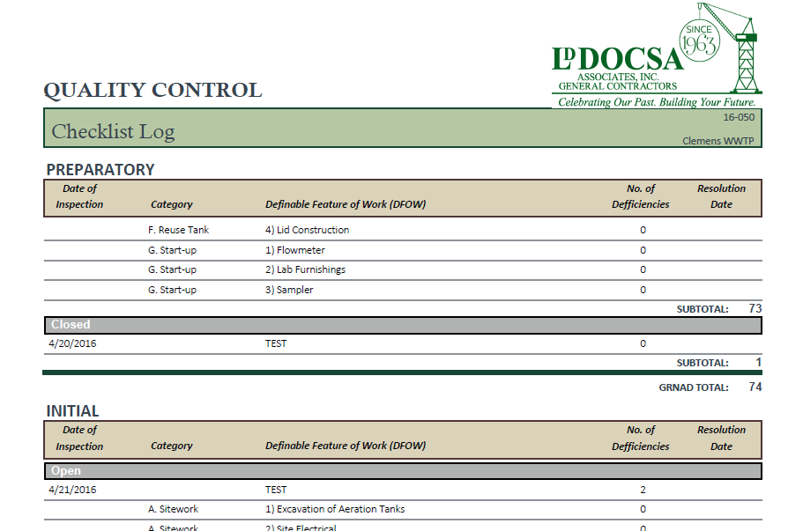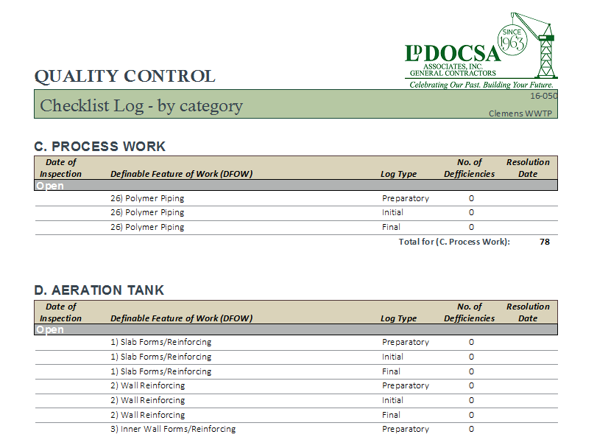

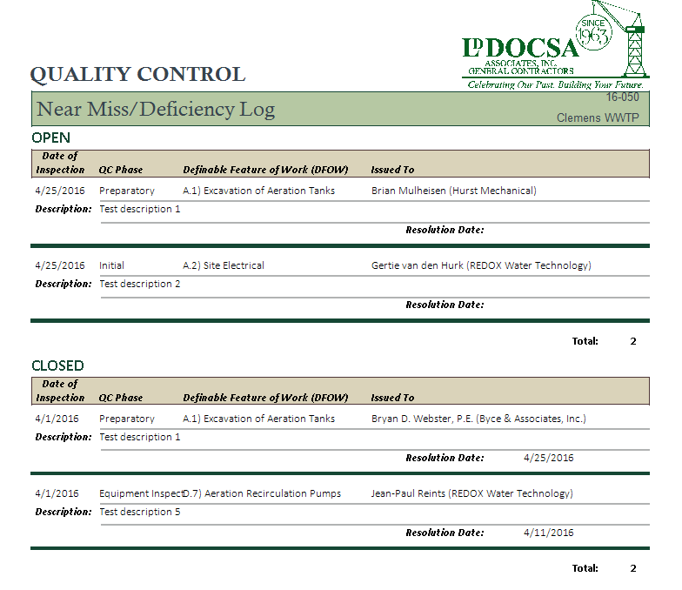

## Forms & Documentations

DFOW Example Preparatory Phase Checklist

 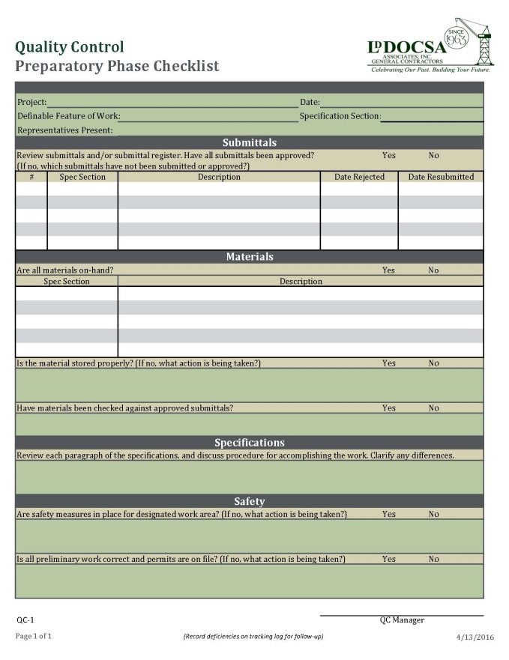

## Initial Phase Checklist Example Finial or Follow-up Phase Checklist Example

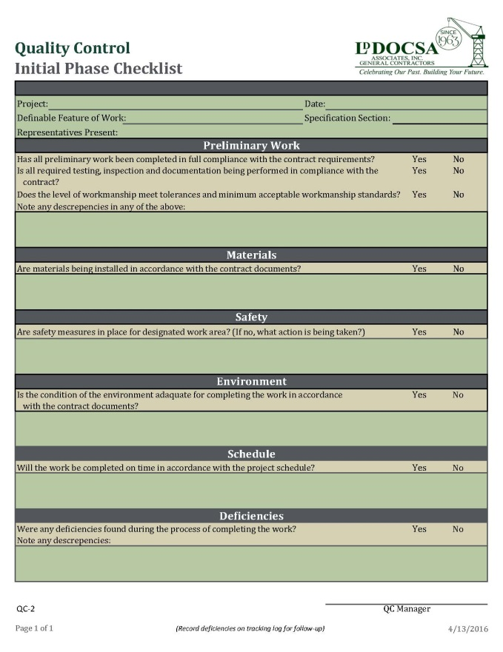 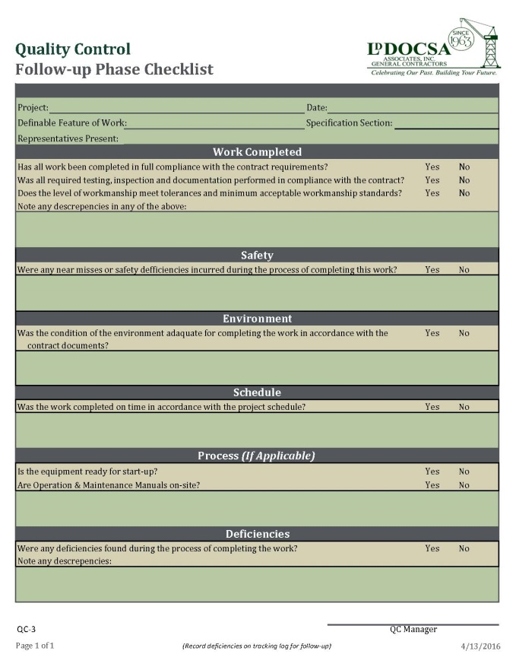

### Equipment Start-up Checklist Example Concrete Pour Checkout Example

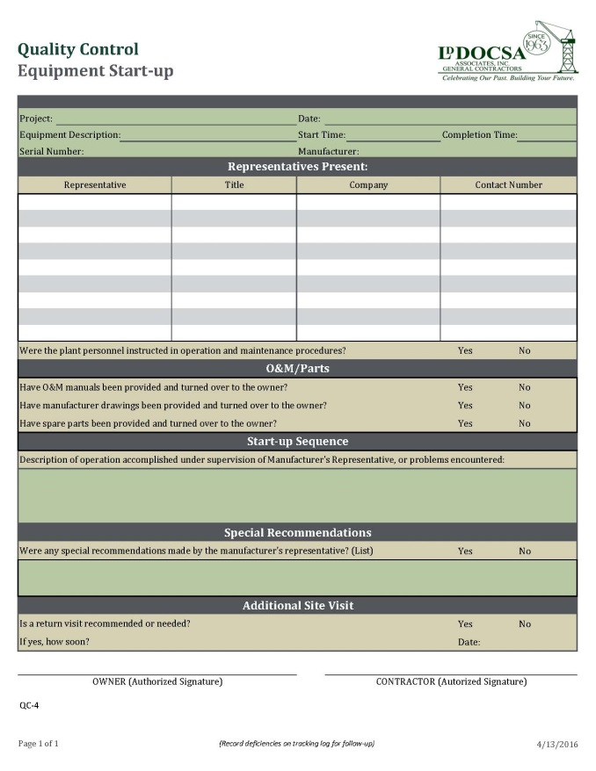 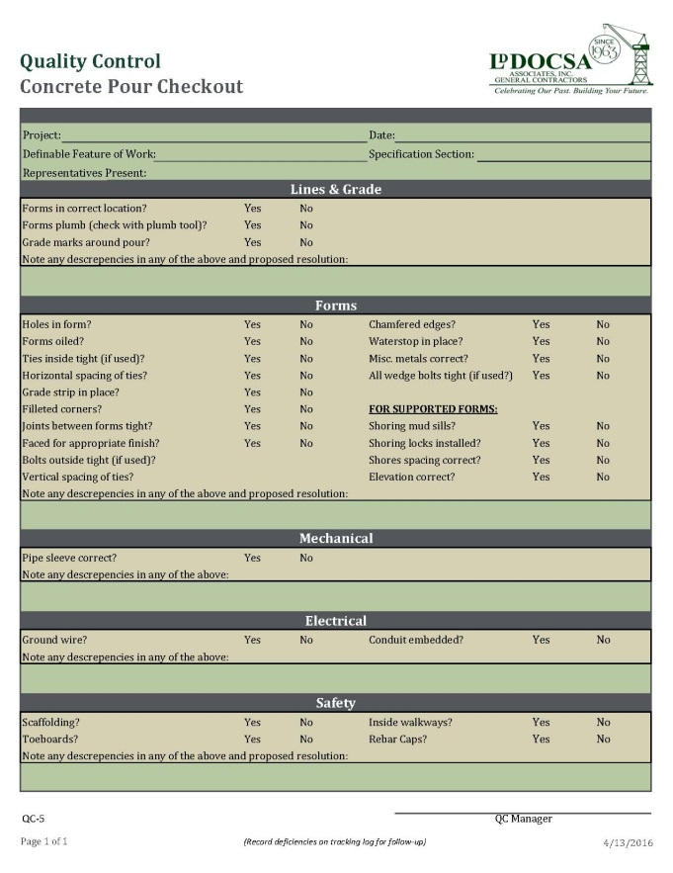

# Safety

## GENERAL

The Safety forms will serve as the checklists for each inspection completed on the project. This project requires the following:

* Daily Safety Audit
* Weekly Safety Audit
* Monthly Safety Audit

This project will also incorporate a project safety sign which will be located on-site. This sign must be updated and maintained daily.

## Project Sign

Below is an example of the project sign. The sign will incorporate writable space for daily/weekly updates.

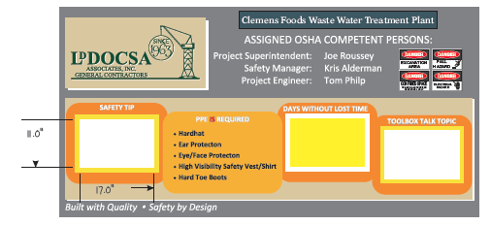

### Tool Box Talks

Tool Box Talks must be performed weekly. The weekly topic shall be written on the project safety sign.

### Safety Tip

Safety tips must also be written on the project safety sign. Examples of safety tips are as follows:

* “A spill or a slip could mean a hospital trip” – Work Smart, Be Safe
* “Working in a safe way means you will live to see another day” – Work Smart, Be Safe
* “If you mess up, don’t hesitate to ‘fess up” – Work Smart, Be Safe
* “Take a shortcut and you will be cutting your life short” – Work Smart, Be Safe
* “If you don’t want to bet your life, don’t gamble with safety” – Work Smart, Be Safe
* “If you are in favor of safety glasses, Say: “EYE” – Work Smart, Be Safe
* “It’s better to arrive late in this world than early in the next” – Work Smart, Be Safe
* "Don't be afraid to ask a dumb question. It's a lot easier to deal with than a dumb mistake." – Work Smart, Be Safe
* "If you don't want your wife to spend your 401(k), don't get hurt on the job today." – Work Smart, Be Safe
* "Remember: Safety is not an accident." – Work Smart, Be Safe
* "Remember to work safe today. Heaven can wait." – Work Smart, Be Safe
* "Your first mistake can also be your last." – Work Smart, Be Safe
* "Remember your safety ABC's: Always Be Careful"– Work Smart, Be Safe

### Lost Time

Days without lost time will also be tracked on the project sign and must be updated daily.

## Safety Audits

This project requires daily, weekly and monthly safety audits. Each audit will have its own form. These forms are available in a fillable .pdf format for use on a pad or phone. Once the audit forms are completed, they must be kept on file for review at any time. The information gathered in these forms will be entered into the Timberline software.

### Logging into Timberline

All safety audits must be logged into Timberline Software for good record keeping.

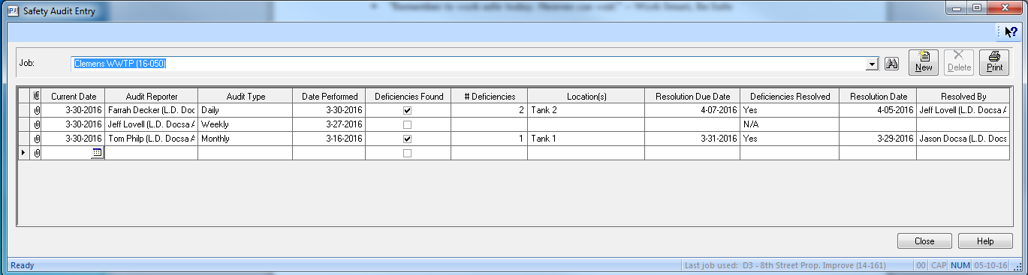

## Near Miss & Deficiency

### Logging into Timberline

When deficiencies are noted, these items must be logged into the Safety Audit Near Miss and Deficiency log. This log is found under the same file structure in the Sage Desktop, with the name “Safety Audit – NM&Def.”

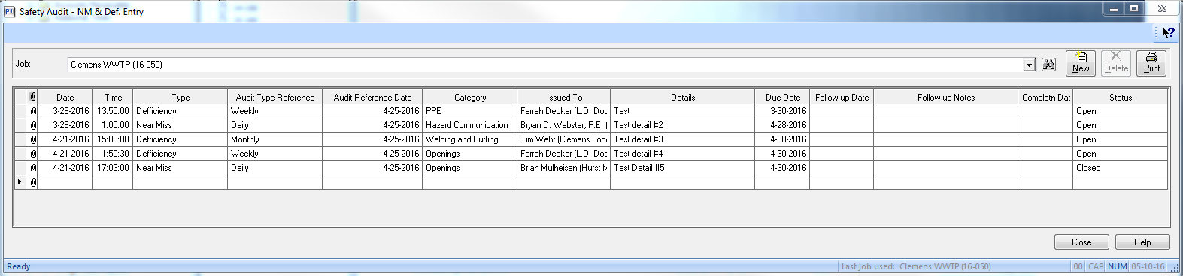

Once the deficiencies are resolved, the resolution date and status must be changed in the “Safety Audit – NM&Def.” log. The status and date of resolution must be noted on both data entry forms.

## Printing Reports

Reports can be found under the Report Folder in the Sage Desktop Task Tree.



An example of each report is as follows:

